**Detailed Game Specification: **

***Course:*** COMP 2659 - 001, Winter 2023

***Instructor:*** Paul Pospisil

***Authour(s):*** Alexander Pham and Kushal Saini

**1. General Game Overview**

Space race is a top-down 2D game where you have control of a rocketship moving through an asteroid field. The game ends when you (rocketship) collide with an asteroid. To score points, you must make it from the starting point at the bottom of the screen to the finish line at top of the screen without getting hit by any asteroids. Everytime you make it to the top, a point is added to your score and the next round begins with your ship at the starting point again. However, if you get hit by any of the asteroids the game is over. When the game is over, you will have the option to press enter to continue, if you want, you can play again or exit. Asteroids are small circles that will move horizontally across the screen in both directions.

To play Space Race, you use the up and down arrow keys. Up arrow to move your rocketship forward and down arrow to move backwards. You cannot move left or right and you can only move vertically.

If you ever get bored of playing alone, there is an option to play with another player. Both players will race against one another to see who can fly the longest without getting hit.

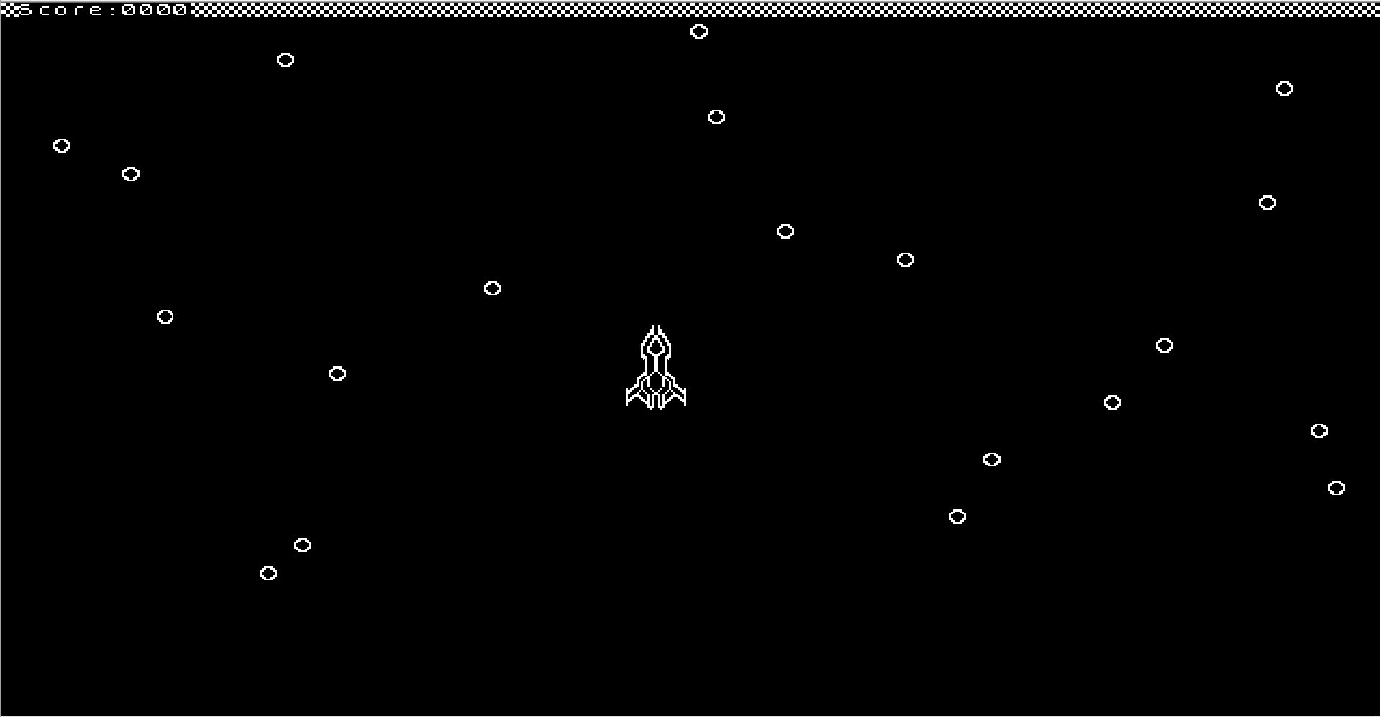

**2. Game play Details for Core 1-Player Version**

**2.1 Objectives and Rules**

**2.1.1 Start Screen**

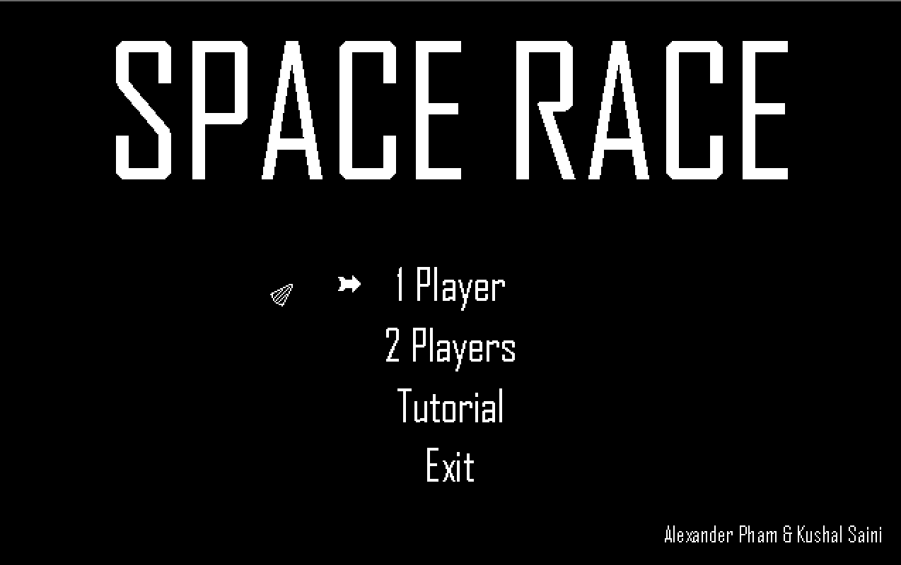

The game first begins with the start menu that displays if you want to play 1-player or 2-player, tutorial (rules/instructions) and quit. The music begins when you start the gameplay.

With the one player version of Space Race, it starts off with the rocketship at the bottom of the screen along with the score of 0. Asteroids then begin to start flying left to right and right to left. There is a safezone at the bottom (height of rocketship) so asteroids cannot hit you as long as you’re in the start area.

**2.1.2 Start State (1-Player)**

A 1-player game begins with a single rocketship at the bottom of the screen. The score and highscore will both start at 0. Once the game is loaded, asteroids will start to fly from left to right and right to left. At which point the player can begin flying their rocket ship. The bottom of the screen is where the safezone is.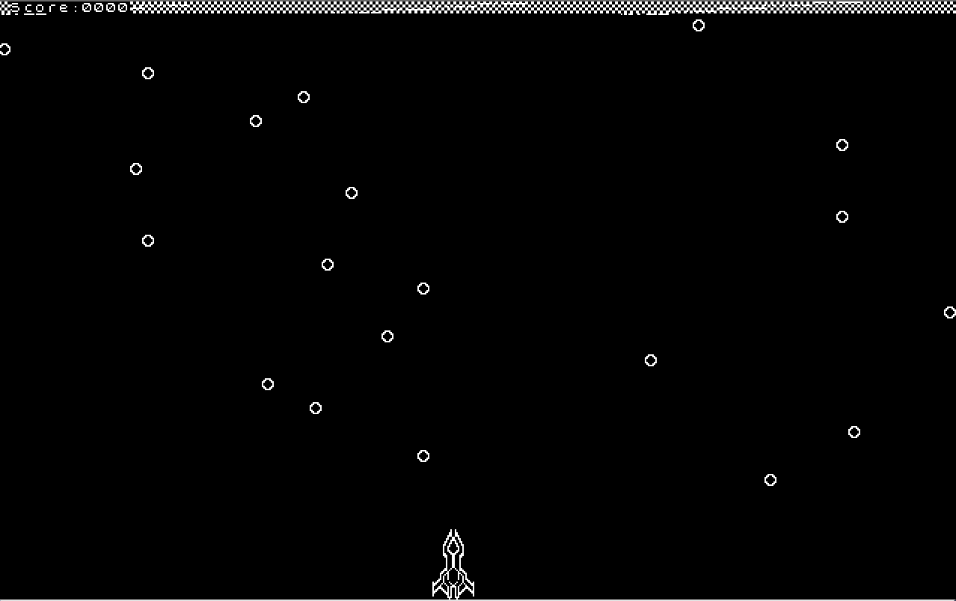

Image: Round start

Rocketship starts at the bottom of screen

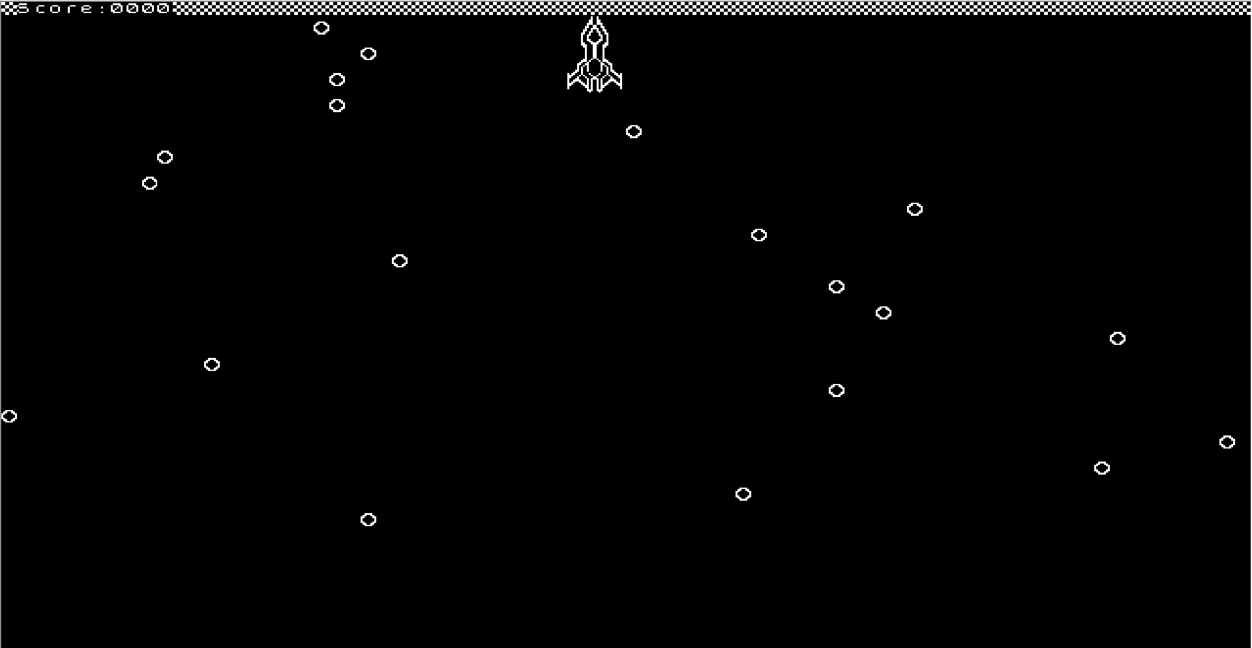

Image: Round End

The spaceship has reached the top of the screen. At this point, the score will update and a new round will begin.

**2.1.3 Game Rules**

Scoring:

* The score is increased by 1 each time the spaceship makes it from the bottom of the screen to the top without getting hit by asteroids.
* If hit by an asteroid, it is game over. If the player decides to play again, the score will start at 0.
* Player will play until the asteroid collides with rocketship and try to get the highest score possible

Asteroids:

* Asteroids move horizontally across the screen in both directions.
* There are 20 rows of asteroids
  + Each row contains 1 asteroid
  + The direction of the asteroids alternates every row
* Asteroids move slower than the rocketship.
* The start point of the spaceship is a safezone with no asteroids.
* The asteroids will be randomly placed, but will have a minimum vertical spacing so that an impassable wall is not produced.

Rocketship:

* The rocketship (player controlled) will move faster than the asteroids.
* Can move upwards and downwards, but not left or right.
* The movement is not continuous. The rocketship will be in motion if either the up or down key is pressed.
* Hitbox is a rectangle, i.e. the border around the rocketship.

**2.1.4 End Screen**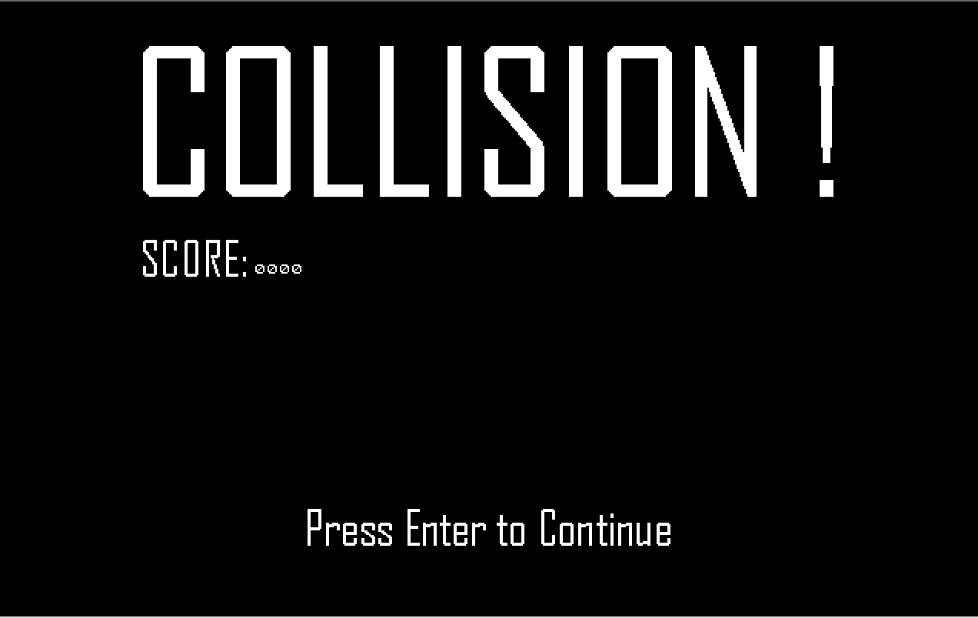

Image: Game Over

If an asteroid hits the spaceship, a game over screen is displayed. The player will have to press enter to continue (back to the main menu) or escape key to exit the game entirely.

**2.2 Objects**

| **Object** | **Properties** | **Behaviours** | **Graphical Image** |
| --- | --- | --- | --- |
| Screen | * Dimensions: 640 x 400   + Score   + Rocketship   + asteroids   + Finish line | * 70 fps * Displays all other objects |  |
| Score | * Integer position   + x: 10px   + y: 0px * Value   + Digit 0   + Digit 1   + Digit 3   + Digit 4 * Dimensions:   + 32px x 10px * Max score of 9999 | * Display player’s current score |  |
| Rocketship | * Integer position   + x: 288px   + y: 353px * Sprite size: 32px x 47px * Direction is either up or down * Speed: 4 pixels/frame | * Player controlled * Move up * Move down |  |
| Asteroid | * Fixed number of asteroids for every round (20) * Size: 8px x 8px * Integer position   + x coordinate   + y coordinate * Direction: 10 are moving to the left and 10 are moving to the right * Speed: 2 pixels/frame | * Moves horizontally across screen * Either: move left or move right |  |
| Finish line | * Dimensions: 640px x 10px * Integer position:   + x: 0   + y: 0 |  |  |

**2.3 Physics**

**2.3.1 Rocket Ship Speed**

* The ship will move at a speed of 4 pixels/frame.

**2.3.2 Asteroid Speed**

* The asteroids will move at a slower speed than the ship (4 pixels/frame).

**2.3.3 Collisions**

* Collisions will be detected by checking if the rocketship hitbox (32px x 47px) is in contact with the asteroids hitbox (2px x 2px) every frame.

**2.4 Asynchronous (Input) Events**

| **Event Name** | **Triggering Input Event** | **Description** |
| --- | --- | --- |
| Move spaceship up | Up arrow key pressed | The rocketship direction is set upwards |
| Move spaceship down | Down arrow key pressed | The rocketship direction is set downwards |

**2.5 Synchronous (Timed) Events**

| **Event Name** | **Triggering Timing** | **Description** |
| --- | --- | --- |
| Asteroids moving on screen | Game start  (moves at 4 pixels/frame) | White circles (asteroids) moving.  10 move left to right, 10 move right to left. |

**2.6 Condition-Based (Cascaded) Events**

| **Event Name** | **Triggering Condition** | **Description** |
| --- | --- | --- |
| Rocketship-asteroids collision | The rocketship collides with an asteroid | Game over screen displayed |
| Debirs-rocketship collision | An asteroid collides with the rocketship | Game over screen displayed |
| Rocketship-finish line collision | Rocketship hits the top of the screen | Rocketship reset to the bottom of screen, score increased by 1 |
| Rocketship-start line collision | Rocketship hits the bottom of the screen | The rocketship is not allowed to move down any further (i.e. move off the screen). |
| Asteroids-boundary collision | If any asteroids hits boundary | If asteroids hits the left boundary, it will “wrap” around and move starting from the right side to the left. Same if asteroids hits the right boundary, it will “wrap” around and move from left to right. |

**2.7 Hypothetical Gaming Session**

The game loads and the player is presented with the main menu. The player selects 1 player mode. The asteroids finish loading and start to move horizontally and the spaceship loads at the bottom of the screen. The player presses the up arrow key to start moving towards the finish line at the top of the screen. The spaceship is moving upwards and is about to collide with an asteroid. To avoid the collision, the player presses the down arrow key and the spaceship stars moving downwards. Once the asteroid passes and the way is clear, the player presses the up arrow key once again. The player repeats this process until the spaceship reaches the top boundary. A point is added to the players score and the next round begins with the players spaceship back at the bottom of the screen. The player starts moving upwards once again, but this time fails to avoid an asteroid and a collision occurs. The game ends and the end screen is displayed with the players score. The player presses enter to continue and is returned to the main menu.

**3. Game Play Details for Core 2-Player Version**

**3.1.1 Start Screen**

The same as 1-player. See 2.2.1.

**3.1.2 Start State (2-Player)**

The start state is very similar to the 1-player start state, except that there are 2 rockets and scores. A 2-player game will have player 1’s rocketship on the left side of the screen and player 2’s rocketship on the right side. Each player will have a current score on their side of the screen. Once the game is loaded for both players, asteroids will begin to fly in just like 1-player mode and then both players will be able to start flying their own rocketship.

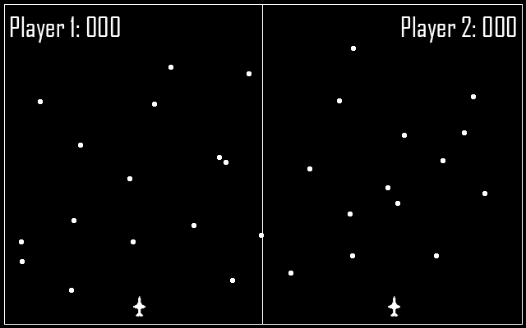

**3.1.3 Gameplay Modifications**

The two players play to see who can get the highest score. If a player gets hit by asteroids, they are out of the game and their score for that round is finalized. The player with the highest score wins the game. Rather than the game being endless like it is in 1-player mode, once a player achieves a score greater than the other player and the other player is out of the game, the game will end.

**3.1.4 End Screen** 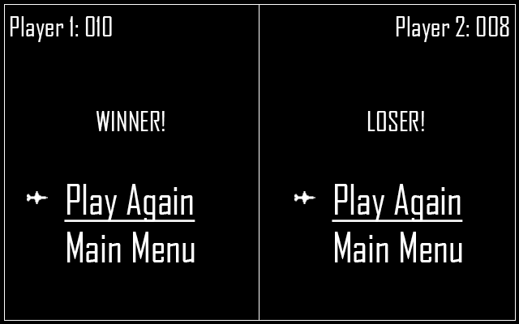

**3.1. Hypothetical 2-Player Sessions**

The game loads and asteroids begin to start flying across the screen. The players start moving the ship upwards, dodging the asteroids.

Situation 1: Player 1 has managed to successfully navigate through the asteroids to the finish line 5 times while player 2 has only done so 2 times. Player 2 is then hit by an asteroid and the game ends. Player 1 is the winner with a score of 5 and player 2 is the loser with a score of 2.

Situation 2: Player 1 has a score of 5 and player 2 has a score of 2. Player 1 then crashes into an asteroid and is out of the game. However, the game continues since player 2 still has a chance to catch up. Player 2 manages to score 4 more points and now has a score higher than player 1. At this point, the game ends with player 2 as the winner.

**4. Sound Effects**

| **Sound Effect Name** | **Brief Description** | **Event which Triggers Playback** |
| --- | --- | --- |
| Main game sound | Space music | Starts when the gameplay begins |
| Controlling rocketship | “Brrrrr” noise | When user moves spaceship |
| Asteroids collision | Colliding sound effect | When rocketship is hit by asteroids |

**5. Additional Features (Time Permitting)**

Difficulty levels:

* Different levels of difficulty for players like easy, medium, hard or extreme
  + Based on the difficulty level, the speed of asteroids vary depending on the level
* Speed of asteroids increases and you progress through rounds

Spaceship controls:

* Control the rocketship in all directions
* Boost

Animations:

* Rocket Exhaust
* Collision explosion

Dynamic music/sounds

* Change in background music as spaceship gets closer to the top
* Different background music for each screen (main menu, game over, etc)

Tutorial screen

* Add a rulebook/instructions on how to play Space Race.